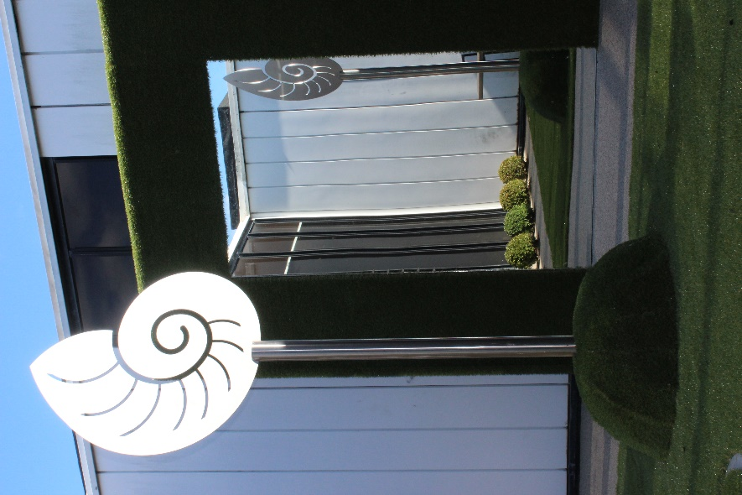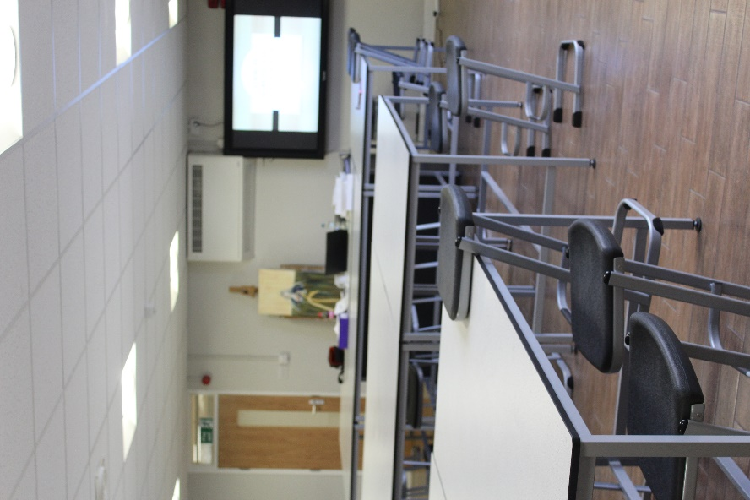

Art, Photography and Textiles form the Visual Arts curriculum at the school. All students study Visual Arts at Key Stage 3 with the option of continuing Art, Art Textiles and Photography at GCSE level.

Year 7 ART
This year is all about building confidence and developing skills that will be used throughout the child's life in art. All children look at the Elements of Art starting with Line and travelling through to working in clay. They not only learn how to use different media but also how to carry out investigations into Art Movements and Artists drawing on this developing understanding to influence their own work.

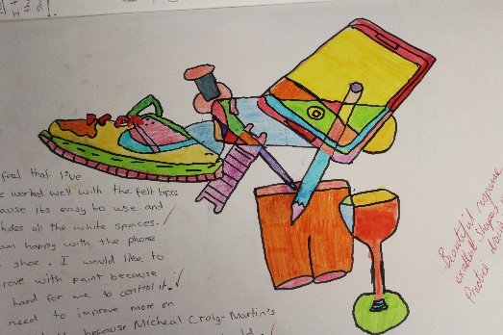

Year 8 ART
The first term is spent investigation the children's school and the Art Movement which influenced the design. They learn how to draw in one point and two perspective and develop their ideas into abstract pieces. Through the investigation part of the project the children will discuss environmental issues and sustainable building materials and how the architect of their school held this very much in the forefront of his mind.

After Christmas linking to previous knowledge the children will look at Hundertwasser and make links to environmental issues and their own environment of Lowestoft. They will draw inspiration from recognisable landmarks around their town and the patterns and colours of Hundertwasser. The final outcome will be realised in Clay.

Year 9 ART
This Year starts with looking at Portraits and the many forms these can take. Children develop their investigation skills, connections with themselves and how to portray a sense of self linked to their own experiences. They explore artists from around the world and how Portraits have been created.
The project culminates in a final piece reflecting the investigation into media and artists.
After Christmas children experience for themselves working to a GCSE Art Brief titled Cells/ Bacteria.
Through this project they will link to the world of Science and use microscopes to study cells and make intricate drawings from the structures they see.
They will further explore media and the way it can interact with ideas not only of other artists but also with their own ideas. They will start to develop a real sense of their personal style in Art and create an exciting portfolio.
The culminated of the project will take many forms and this will be decided by the students themselves.

Year 10 and 11 GCSE Fine ART 60% course work 40% examThese two years are all about expanding an already expanding idea of what art can be and developing further the child’s own artistic skills.
Year 10 follows the theme Natural Forma and Year 11 follow Man Made
Both projects start with teacher lead activities to investigate media and artists and then the children are encouraged to develop their own portfolio based on the theme. The portfolios created will be of a high standard and will show case the best of their work. These folders will form the evidence for not only their GCSE Grade but also for submission at interview for college places.

